CORNERSTONE PROJECT WORK
SALARY ENROLL PAY SYSTEM
A C++ OOP-Based Payroll, PF & ESIC Management System
Cornerstone project work submitted to Aditya University in partial fulfilment of the requirements for the award of the Degree of
B.Tech. degree
in
Computer Science & Engineering (2026-2027)
SUBMITTED BY
Tirumala Srinivas | 25B11AAID13
N. Lasya Snehitha | 25B11AI841
D. Janani | 25B11AI274
Ch. Charan | 25B11AI192
UNDER THE GUIDANCE OF
Thorati Vijaya Lakshmi
Assistant Professor
Department of Artificial Intelligence & Machine Learning

Department of Computer Science & Engineering
Aditya University, Aditya Nagar, ADB Road,
Surampalem, Kakinada, District, Andhra Pradesh, India - 533437
DECLARATION
We hereby declare that the Cornerstone project work entitled "SALARY ENROLL PAY SYSTEM" is being submitted by us for the award of the B.Tech. Degree in Computer Science and Engineering, Aditya University, Aditya Nagar, ADB Road, Surampalem, and is a record of original work carried out by us. We further declare that this project work has not been submitted, either in full or in part, for the award of any degree or diploma in this or any other institution. We also confirm that this work has been carried out with academic honesty and complies with the Institutional Academic Integrity and AI Usage Policy.
Submitted By
Tirumala Srinivas | 25B11AAID13
N. Lasya Snehitha | 25B11AI841
D. Janani | 25B11AI274
Ch. Charan | 25B11AI192
Place: SURAMPALEM
Date: 16-10-2026
DEPARTMENT OF COMPUTER SCIENCE & ENGINEERING
ADITYA UNIVERSITY, ADITYA NAGAR,
SURAMPALEM.
CERTIFICATE
This is to certify that the cornerstone project entitled "SALARY ENROLL PAY SYSTEM" is being submitted by Tirumala Srinivas, N. Lasya Snehitha, D. Janani, Ch. Charan in partial fulfilment for the award of B.Tech. Degree from Aditya University, is a record of original work done by them under my supervision. The contents of this project, in full or in parts, have not been submitted to any other Institute or University for the award of any degree or diploma.
Project Guide
Thorati Vijaya Lakshmi
Assistant Professor
Department of CSE
Aditya University
ACKNOWLEDGEMENT
It is with immense pleasure that we express our sincere gratitude to our Cornerstone Project Guide, Thorati Vijaya Lakshmi, Assistant Professor, who has guided us throughout the project. Her valuable support, encouragement, and guidance have greatly contributed to the successful completion of this work.
We would like to thank our Deputy Heads of the Department, Dr. Bolla Manikyala Rao, Associate Professor, Dr. Dasari Veeraswamy, Assistant Professor, Department of CSE, for their support and valuable suggestions.
Our deepest thanks to our Head of the Department, Dr. Kovvuri Naga Bhargavi, Associate Professor & HOD, for her inspiration and for providing all the necessary facilities and resources required for this project.
We also extend our sincere thanks to Dr. M.V. Rajesh, Associate Dean, School of Computing, for his encouragement and support during our project.
We would like to express our sincere gratitude to Dr. G. Suresh, Registrar; Dr. A. Ramesh, Pro Vice-Chancellor (Engineering & Sciences); Dr. S. Rama Sree, Pro Vice-Chancellor (Academics); Dr. M.B. Srinivas, Vice-Chancellor; and Dr. M. Sreenivasa Reddy, Deputy Pro Chancellor and Management, Aditya University, for providing excellent infrastructure and state-of-the-art laboratories.Finally, we would like to thank the faculty members, lab technicians, non-teaching staff, and our friends who have directly or indirectly supported us in completing this Cornerstone project successfully. D Tirumala Srinivas
N. Lasya Snehitha
D. Janan
Ch. Charan
ABSTRACT
The Salary Enroll Pay System is a web-based payroll and statutory contribution management application built around a calculation engine written in C++ using Object-Oriented Programming. It is designed for businesses that employ many workers and have to prepare salary, Provident Fund (PF) and Employees' State Insurance (ESIC) data every month.
The system keeps employee master records, including UAN and ESIC/IP details and supporting documents, so that permanent information is entered only once. Every month, the administrator enters attendance, NCP days, wages, overtime, advances and the separate PF and ESIC wage values. The C++ engine then calculates gross earnings, employee deductions and net payable salary, and processes the applicable PF and ESIC contributions with separate, configurable rules.
Each payroll month is preserved as a separate record, and finalised payroll does not change when employee details are edited later. The system validates incomplete or invalid records, separating errors that stop processing from warnings that need review. It generates employee-wise and summary reports and prepares structured export files for the EPFO and ESIC employer-portal workflows. Generating a file is not the same as submitting a return, and the formats must be verified against the current official specifications.
The project demonstrates classes and objects, encapsulation, abstraction, inheritance, polymorphism, constructors, function overloading, file handling, the STL and exception handling through a practical business application, and helps reduce repetitive manual work while improving the consistency of payroll records.
ABBREVIATIONS
OOP– Object-Oriented Programming
C++– C Plus Plus
PF– Provident Fund
ESIC– Employees' State Insurance Corporation
EPFO– Employees' Provident Fund Organisation
UAN– Universal Account Number
IP– Insured Person
ECR– Electronic Challan cum Return
EE– Employee Contribution
ER– Employer Contribution
EPS– Employees' Pension Scheme
EDLI– Employees' Deposit Linked Insurance
NCP– Non-Contributory Period
OT– Overtime
STL– Standard Template Library
UI– User Interface
API– Application Programming Interface
CRUD– Create, Read, Update and Delete
PDF– Portable Document Format
ID– Identification
LIST OF FIGURES
Figure 1.1 System Architecture of Salary Enroll Pay System
Figure 1.2 Monthly Payroll Workflow
Figure 1.3 Overall System Flowchart
Figure 2.1 Login Screen
Figure 2.2 Dashboard
Figure 2.3 Employee Registration
Figure 2.4 Employee Profile
Figure 2.5 Attendance and Wages Entry
Figure 2.6 Payroll Processing
Figure 2.7 PF Management
Figure 2.8 ESIC Management
Figure 2.9 Validation Errors and Warnings
Figure 2.10 Payroll History
Figure 2.11 Reports
Figure 2.12 Exports
LIST OF TABLES
Table 1.1 Project Overview
Table 1.2 Phase-wise Scope of the Project
Table 1.3 Functional Requirements of the System
Table 1.4 Planned Modules and Their Functions
Table 1.5 Inputs and Outputs
Table 1.6 Hardware and Software Requirements
Table 1.7 System Input Validation Rules
Table 1.8 Team Members and Planned Responsibilities
Table 2.1 OOP Concepts Used in the Project
Table 2.2 Employee Data Fields
Table 2.3 Monthly Attendance and Wage Data Fields
Table 2.4 Proposed Class Responsibilities
Table 2.5 Illustrative Payroll Calculation
Table 2.6 Sample Test Cases and Expected Results
TABLE OF CONTENTS
CONTENTS | PAGE NO
Title Page | I
Declaration | II
Certificate | III
Acknowledgement | IV
Abstract | V
Abbreviations | VI
List of Figures | VII
List of Tables | VIII
CHAPTER – 1 Project Planning | 1
1.1 Problem Statement | 1
1.2 Project Objectives | 4
1.3 Planned Modules | 6
1.4 System Architecture (Algorithm & Flowchart) | 11
1.5 Team Members and Planned Responsibilities | 16
CHAPTER – 2 Project Implementation | 17
2.1 OOP Concepts Used for Implementation | 17
2.2 Code | 21
2.3 Output Screens | 24
CHAPTER – 3 Conclusion & Future Scope | 31
3.1 Conclusion | 31
3.2 Future Scope | 33
References | 35

CHAPTER – 1
PROJECT PLANNING

1.1 Problem Statement

1.1.1 Background
Almost every business that employs people has to deal with payroll once a month. When a company has only a handful of workers, a notebook or a simple spreadsheet is enough. The trouble starts when the number of workers grows to dozens or hundreds. At that point the salary is no longer just "days worked multiplied by daily wage". The employer also has to think about overtime, advances that were given earlier, other deductions, and the contributions that have to be made towards the Provident Fund (PF) and the Employees' State Insurance Corporation (ESIC).
Each of these items follows its own rules. PF and ESIC are calculated on wage bases that may be different from each other, and both may be different from the salary that is actually paid to the worker. On top of this, the employer has to keep each worker's UAN and ESIC/IP number, check joining and exit dates, count the non-contributory period (NCP) days, and finally prepare the data in the form that the employer portals expect. Doing all this by hand every month is slow, repetitive and easy to get wrong.
Our project, the Salary Enroll Pay System, is an attempt to take this monthly burden and turn it into a clear and repeatable workflow. The permanent details of an employee are entered once and reused every month. The details that change every month, such as attendance, overtime and advances, are entered for the selected month. A calculation engine written in C++ using Object-Oriented Programming then does the arithmetic in a consistent manner and reports anything that looks wrong.

1.1.2 A Real-World Scenario
To understand the problem better, imagine a small manufacturing company that employs 200 workers. At the end of every month the payroll staff has to carry out a long list of tasks:
- Update the attendance and the working days of all 200 employees.
- Calculate monthly wages and overtime for each of them.
- Record advances and other authorised deductions.
- Decide the PF wage and the ESIC wage separately for every employee.
- Calculate the employee-side and the employer-side contributions.
- Handle EPS, EDLI and NCP-related fields wherever they apply.
- Check joining dates, exit dates and employee identifiers.
- Work out the final payable salary and prepare payroll summaries.
- Prepare the statutory data and correct the mistakes found before submission.
If the same employee information has to be typed again every month, the workload becomes even heavier. A single wrong digit in an identification number, a missed advance or a wrongly counted NCP day can lead to an incorrect salary or a rejected upload file. These are the real difficulties that our project tries to reduce.
It is important to be honest about what the system can and cannot do. It does not remove the employer's responsibility to verify the records or to follow the statutory rules that are in force at the time. What it does is reduce the manual effort and help to catch mistakes before the data is processed.

1.1.3 Proposed Problem Statement
Based on the above discussion, the problem statement of our project is as follows:
"To develop a web-based Payroll and Statutory Contribution Management System using C++ Object-Oriented Programming that centralizes employee records, automates monthly salary and overtime calculations, processes applicable PF and ESIC contributions, maintains payroll history, and generates structured reports and export files to reduce repetitive manual work and improve payroll accuracy."
Table 1.1: Project Overview
Item | Details
Project title | Salary Enroll Pay System
Project domain | Payroll management and statutory compliance
Academic subject | Object-Oriented Programming using C++
Application type | Web-based management system
Intended users | Business owners, payroll staff and authorised administrators
Primary problem | Repetitive monthly payroll, PF and ESIC processing
Core technology | C++ OOP calculation engine with a web interface and backend
Main outputs | Net salary, contribution reports, monthly payroll history and export files
Future submission support | EPFO ECR-compatible file and ESIC Excel upload file, subject to verified official formats

1.1.4 Need for the Proposed System
Without a proper system, an employer usually keeps employee details in one file, attendance in another, and the PF and ESIC calculations in a third. Every month the same names and numbers are copied from one place to another. This copying is where most errors enter. The proposed system removes the need to copy by keeping everything in one place and by reusing the permanent information automatically.
The system also checks the data before the calculation is accepted. For example, if an employee who needs PF processing has no UAN, or if a negative number of overtime hours has been typed, the system shows a message instead of quietly producing a wrong result. This idea of checking first and calculating afterwards is one of the main reasons the project is useful.
Another important need is history. Once a month's payroll is finalised, it should stay exactly as it was. If the employer later edits an employee's name or joining details, the old payroll should not change silently. The system therefore keeps every payroll month as a separate saved record, so that earlier months can always be opened, reviewed and reported again.
Finally, the system recognises that PF and ESIC are different things. They have different rules, different wage bases and different reporting formats. Rather than forcing every employee into a single formula, the system keeps the two calculations separate and keeps the rules configurable, so that a change in a statutory rule does not require rewriting the whole program.

1.1.5 Project Scope
To keep the project achievable within the available time, we have divided the work into three phases. The first phase is the compulsory core of the project, and the later phases extend it.
Table 1.2: Phase-wise Scope of the Project
Phase | Features included
Phase 1 – Core project | Employee registration and document management; monthly attendance and wage entry; salary, OT and advance calculations; configurable PF and ESIC processing; payroll history and monthly reports; C++ OOP calculation engine; basic validation and audit trail.
Phase 2 – Statutory exports | Verified-format PF ECR generation; official-template-compatible ESIC Excel generation; export previews and validation; reconciliation and export history.
Phase 3 – Advanced features | Bulk employee and bulk monthly data import from spreadsheets; multiple companies or establishments; maker-checker approval; salary slips and printable PDF reports; automated reminders; deeper analytics and backups.

Throughout this report we have tried to be clear about the difference between what is planned and what is finished. Where a feature belongs to a later phase, we say so instead of describing it as if it already exists.

1.2 Project Objectives
The main objective of the Salary Enroll Pay System is to make monthly payroll and statutory contribution processing faster, more consistent and less dependent on repeated manual work. This main aim is broken down into the following specific objectives.
- To centralise employee master information in one place.
- To maintain UAN, ESIC/IP numbers and the relevant employee documents.
- To avoid entering permanent employee details again every month.
- To record monthly attendance, wages, overtime and advances.
- To support separate salary, PF wage and ESIC wage values.
- To calculate net salary and the applicable statutory contributions.
- To maintain employee-wise and month-wise payroll records.
- To track NCP days and other required statutory details.
- To generate clear payroll, PF and ESIC reports.
- To prepare structured export files for the relevant employer portals.
- To validate incomplete records and flag calculation errors.
- To demonstrate C++ OOP concepts through a practical business application.

1.2.1 Explanation of the Objectives
The first three objectives are about employee records. A payroll system is only as good as the data behind it, so we wanted the employee record to be the foundation of the application. Each worker is registered once with personal, employment and statutory details, and from then on the record is simply reused.
Objectives four and five are about monthly data. Attendance, overtime, advances and other deductions change every month, and the PF and ESIC wage bases may differ from the salary actually paid. The system must therefore accept these values separately instead of assuming that one number fits all three purposes.
Objectives six to nine are about calculation and reporting. Here the C++ engine calculates gross earnings, deductions, net pay and the contributions, and the reporting side presents the results in a form that the employer can read and compare from month to month.
Objectives ten and eleven are about export and validation. The system should not only calculate the numbers but also organise them for the employer portals, and it should warn the user about missing or invalid data before a file is generated. Objective twelve is the academic objective: all of this should be done in a way that genuinely uses the Object-Oriented Programming concepts we learned in C++.

1.2.2 Functional Requirements
Table 1.3: Functional Requirements of the System
ID | Requirement | Description
FR-1 | Administrator login | Only an authenticated administrator can open the system.
FR-2 | Employee registration | Add, edit, search and deactivate employees with statutory identifiers.
FR-3 | Document management | Upload, view and replace employee documents such as the E-Pehchan PDF.
FR-4 | Monthly data entry | Enter paid days, NCP days, wages, OT, advances and other deductions for a selected month.
FR-5 | Payroll calculation | Compute gross earnings, employee deductions and net payable salary.
FR-6 | PF processing | Compute PF wage, EE, ER, EPS and related components using configurable rules.
FR-7 | ESIC processing | Compute ESIC wage and employee/employer contributions separately from PF.
FR-8 | Validation | Distinguish errors that stop processing from warnings that need review.
FR-9 | Payroll history | Preserve every finalised payroll month as a separate record.
FR-10 | Reports | Generate salary statements, summaries and statutory reports.
FR-11 | Exports | Generate PF ECR-compatible and ESIC Excel files after validation.
FR-12 | Audit trail | Record who changed or finalised payroll data and when.

1.2.3 Non-Functional Requirements
Besides the functions listed above, the system has to satisfy a few quality requirements. Accuracy is the most important one, because a payroll system that gives wrong numbers is worse than no system at all. Security is also essential, since the application stores salary details, UANs, ESIC/IP numbers and documents. Usability matters because the person using the system every month is a payroll administrator and not a programmer, so the screens must be clear and the amounts easy to read. Maintainability is important because statutory rules change from time to time, and the code should be organised so that a rule can be updated without breaking everything else. Finally, reliability requires that finalised payroll never changes silently.

1.3 Planned Modules
The Salary Enroll Pay System is divided into several modules. Each module has one clear responsibility, which makes the system easier to build, test and explain. The modules appear in the same order in which a payroll administrator would use them during a month.
Table 1.4: Planned Modules and Their Functions
Module | Main function
Login | Secure administrator access to the application
Dashboard | Quick overview of payroll status, totals and alerts
Employee Master | Register, edit, search and deactivate employees; manage documents
Attendance & Monthly Wages | Record the data that changes every month
Payroll Processing | Calculate earnings, deductions and net payable salary
PF Management | PF wage, EE, ER, EPS and related contribution records
ESIC Management | ESIC wage and contribution records for insured employees
Payroll History | Preserve and reopen previous payroll months
Reports & Exports | Statements, summaries, PF ECR file and ESIC Excel file
Settings | Company information and statutory rule configuration

1.3.1 Dashboard Module
The dashboard is the first screen the administrator sees after logging in. It gives a quick picture of the payroll position of the business without opening every other page. The idea is that the administrator should be able to tell at a glance whether the month's payroll is pending, in progress or complete, and whether anything needs attention.
Main features:
- Total number of registered employees.
- Number of employees with PF and ESIC records.
- The selected payroll month.
- Payroll runs completed or pending.
- Total gross wages and total net payroll payable.
- Total employee-side deductions and total employer-side contributions.
- Records with missing or invalid information.
- Recent payroll activity and export history.
All financial figures on the dashboard are meant to be calculated from the actual saved records. If any sample figures are shown for demonstration, they must be clearly marked as sample data so that nobody mistakes them for real payroll.

1.3.2 Employee Master Management Module
This is the foundation of the whole application. Every employee is registered once, and the stored details are reused for all later payroll months. This directly solves the problem of typing the same information again and again.
The employee record is divided into three parts. The personal and employment part holds the employee ID, full name, department or designation, joining date, employment status and exit date where applicable. The statutory part holds the UAN, the ESIC/IP number, PF and ESIC applicability details, relevant statutory dates and any other required identifiers. The document part holds the E-Pehchan PDF or other supporting document, its category and upload date, and allows an authorised user to replace an outdated document.
Important functions of this module:
- Add a new employee and edit an existing one.
- Search by name, employee ID, UAN or ESIC/IP number.
- Prevent inappropriate duplicate records.
- View the complete employee profile.
- Deactivate employees who have left, while keeping their historical payroll records safe.
Because UANs, ESIC/IP numbers and documents are sensitive, the module is designed so that the employee list does not show full identification numbers unnecessarily, and documents are opened only through secure view and download options.

1.3.3 Attendance and Monthly Wage Entry Module
This module records everything that changes from month to month. After the administrator selects a payroll month and year, the module accepts the following details for each employee.
The paid working days tell the system how many days the employee is to be paid for. The NCP days record the non-contributory period, which is needed for the PF data. The basic wages and earnings store the wage components, while OT hours and OT amount store the overtime quantity and the calculated or approved overtime pay. The advance field holds the amount to be recovered this month, and other deductions hold any further authorised recoveries. Finally, the PF wage and the ESIC wage store the wage bases to be used for the two statutory calculations.
A key design decision here is that the system supports company-specific payroll policies. Instead of forcing every employee into one formula, the PF wage and the ESIC wage are separate fields, so that the policy of the company and the statutory requirements can both be respected.

1.3.4 Payroll Processing Module
This module calculates what the company owes the employee. It combines the monthly inputs with the stored employee information and produces the gross earnings, the employee deductions and the net payable salary. The basic calculation model is:
Gross Earnings = Regular Earnings + OT Amount + Other Earnings
Net Pay = Gross Earnings − Employee Deductions
Employee deductions can include the applicable employee PF, the employee ESIC, advance recovery and other authorised deductions. One rule we are careful about is that each item must be counted exactly once. The module also shows the employer-side PF and ESIC contributions separately, because they are costs to the company and are not deducted from the employee's net salary.

1.3.5 PF Management Module
The PF module handles the Provident Fund related wage and contribution records for each applicable employee. For every such employee and every month it deals with the PF wage, the employee contribution (EE), the employer contribution (ER), the EPS contribution where applicable, EDLI and other required components, the NCP days, and the relevant joining and exit details.
The module is designed to take into account eligibility, wage ceilings, contribution allocation, rounding and exceptions. It must not simply apply one hard-coded percentage to every worker. For this reason the rules are meant to be kept as configuration for the selected period and verified against the official requirements before use. The module also provides employee-wise and month-wise contribution totals.

1.3.6 ESIC Management Module
The ESIC module maintains the contribution information required for insured employees. It supports ESIC/IP number verification, the ESIC wage base, the employee and employer contributions, the contribution period, the number of days and applicable wage fields, zero-wage reasons or other required exceptions, and joining or exit information where applicable.
The module also gives missing-data and invalid-record warnings and produces a month-wise ESIC summary. PF and ESIC calculations are deliberately kept separate, since they follow different rules and can use different wage bases.

1.3.7 Monthly Payroll History Module
Every payroll month is preserved as a separate record. For example, the system keeps the June 2026, July 2026, August 2026 and September 2026 payrolls side by side. Each record holds the payroll period, the employees processed, the totals, the status, the rule version that was applied and the generation history.
The administrator can open any previous month, review its calculations and download its reports again. A very important property is that a finalised payroll does not change silently when an employee's current master information is edited later. This is achieved by saving a snapshot of the payroll at the time of finalisation.

1.3.8 Reports and Exports Module
This module turns the calculated data into documents. The reports planned for the system are the employee-wise salary statement, the monthly payroll summary, the employee deduction report, the employer contribution report, the PF contribution report, the ESIC contribution report, the missing information report, the month-to-month payroll comparison, the export validation report and the export history.
The reports help the employer compare totals and catch mistakes before anything is submitted. The same module is also responsible for the main distinguishing feature of the project, the government-portal export, which is described next.

1.3.9 Government-Portal Export (Distinguishing Feature)
Most basic salary calculators stop after printing the net salary. Our project goes one step further. It organises the calculated numbers in the format required by the relevant employer portal.
For PF, the system is planned to generate a downloadable text file in the currently applicable ECR format, after the official specification has been verified. For ESIC, it is planned to generate an Excel workbook that matches the current official ESIC employer contribution template, with the IP number, employee name, days, wages and other required fields.
The export workflow runs in a fixed order: select the payroll month; review the employee-wise calculations; check the identifiers and wage fields; show errors and warnings; finalise the payroll after authorisation; generate the file using the verified format; preview and download it; upload it manually through the employer portal; and finally record the export date, period and file type.
We want to be very clear about one point. Generating a file is not the same as submitting a return. The project provides export and validation only. It does not claim automatic integration with the government portals or guaranteed acceptance of the file, and since official formats can change, the exporters must always be checked against the current specification.

1.3.10 Inputs and Outputs of the System
Table 1.5: Inputs and Outputs
Stage | Inputs | Outputs
Employee Master | Name, ID, joining date, UAN, ESIC/IP number, documents | Stored employee profile
Monthly Entry | Paid days, NCP days, wages, OT, advances, deductions, PF wage, ESIC wage | Validated monthly records
Payroll Processing | Employee profile and monthly records | Gross earnings, deductions, net pay
PF / ESIC Engines | PF wage, ESIC wage, rule configuration | EE, ER, EPS, ESIC contributions
Reports & Exports | Finalised payroll run | Statements, summaries, ECR file, ESIC Excel file

1.4 System Architecture (Algorithm & Flowchart)

1.4.1 System Architecture
The Salary Enroll Pay System follows a layered architecture in which the user interface is kept separate from the payroll engine. This separation is important for two reasons. First, the calculation logic can be tested on its own without opening a browser. Second, our academic requirement is that the core processing is genuinely written in C++ using OOP, and a web frontend by itself would not demonstrate that.
The system has four main layers:
- Frontend (React): the dashboard, employee forms, monthly payroll tables, contribution previews, reports and export controls.
- Backend (Node.js and Express): authentication, authorisation, validation, API endpoints, database operations, secure document handling and calls to the calculation engine.
- C++ OOP calculation engine: payroll processing, contribution calculations, validation and structured calculation results.
- Database and secure file storage: employee records, payroll periods, applicable rules, calculation results, audit history and restricted document storage.
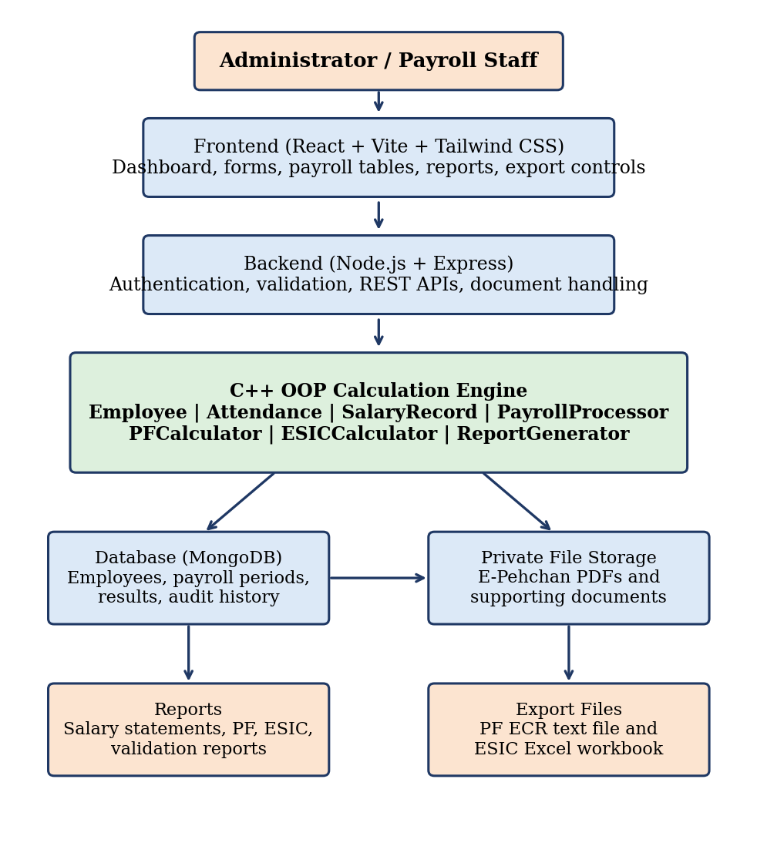
Figure 1.1: System Architecture of Salary Enroll Pay System
The C++ engine can start as a separate executable that the backend calls through a defined interface, and it can later be converted into a service. An important safety rule is that untrusted input from the browser must never be passed to an unrestricted shell command. Data is passed to the engine only in a controlled, validated form.

1.4.2 Technologies Planned
Table 1.6: Hardware and Software Requirements
Component | Details
Frontend | React, Vite, JavaScript and Tailwind CSS
Backend | Node.js and Express
Database | MongoDB with schema validation and indexes
Core processing | C++ with separate header, source and test files
Authentication | Password hashing, authenticated sessions or tokens, role-based access
File generation | C++ and backend libraries for text files and Excel workbooks
Development tools | Code editor, C++ compiler, Node.js runtime, Git
Hardware | A standard laptop or desktop computer with a modern web browser

1.4.3 Monthly Workflow
From the administrator's point of view, the monthly work is a simple five-step cycle. Step one, the employee master, is done only when a new worker joins. Steps two to five are repeated every month.
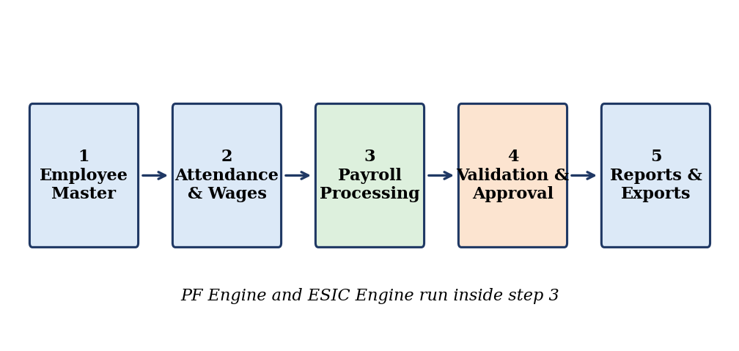
Figure 1.2: Monthly Payroll Workflow

1.4.4 Algorithm
The algorithm of the proposed system is given below.
Step 1: Start the application and authenticate the administrator.
Step 2: Load the employee master records.
Step 3: Register a new employee if the employee does not already exist.
Step 4: Select the payroll month and year.
Step 5: Enter or import the monthly attendance and wage details.
Step 6: Validate the employee identifiers and the monthly inputs.
Step 7: Determine the applicable earnings, deductions, PF wage and ESIC wage.
Step 8: Calculate the gross earnings and the net payable salary.
Step 9: Calculate the applicable PF, EPS and other statutory components.
Step 10: Calculate the applicable ESIC contributions.
Step 11: Display the employee-wise results and the monthly totals.
Step 12: Resolve the validation errors and review the warnings.
Step 13: Save a draft, or finalise the approved payroll run.
Step 14: Generate the reports and the validated export files.
Step 15: Download the required files and retain the export history.
Step 16: Stop.

1.4.5 Flowchart
The flowchart below shows the same process graphically. The decision point after data entry is the heart of the design: if the inputs are not valid, the user is taken back to correct them, and only valid data moves on to the calculation.
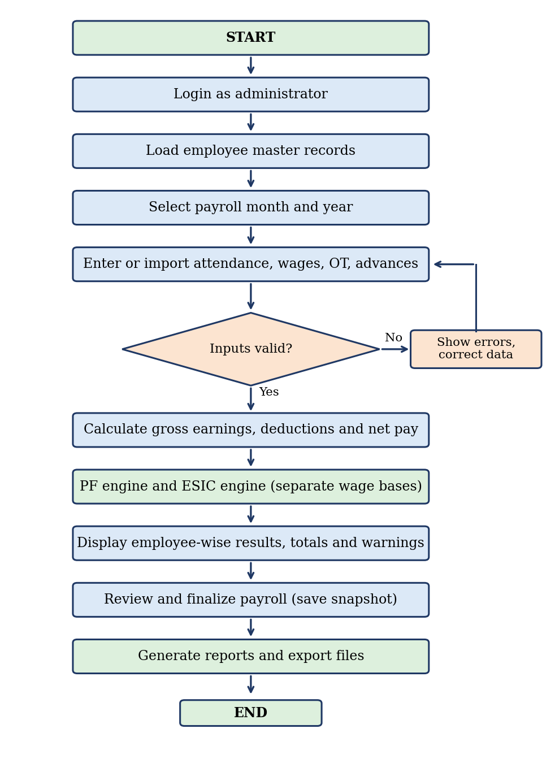
Figure 1.3: Overall System Flowchart

1.4.6 Important Validations and Error Handling
A payroll system should not simply calculate and display numbers. It should also find the problematic records. We therefore plan to include the following checks, and we distinguish between an error, which prevents processing, and a warning, which needs review but allows the user to continue.
Table 1.7: System Input Validation Rules
Check | Type | Reason
Missing UAN where PF processing is required | Error | PF record cannot be prepared without it
Missing or invalid ESIC/IP number for an applicable employee | Error | ESIC record cannot be prepared
Duplicate employee records | Error | Prevents double payment and double reporting
Negative wages or OT hours | Error | Not a valid input
Attendance inconsistent with the period | Warning | Needs human review
Incorrect NCP days or missing exit information | Error / Warning | Affects PF data
PF or ESIC wage missing where required | Error | Contribution cannot be computed
Contribution rule not configured for the period | Error | No verified rule to apply
Duplicate payroll for the same employee and month | Error | Prevents duplicate processing
Totals not reconciling with employee-wise records | Error | Indicates a calculation problem
Export file missing mandatory columns | Error | File would be rejected

1.4.7 Security and Data Management
Since the application stores UANs, ESIC/IP numbers, employee documents and salary information, security is a core requirement and not an afterthought. The planned measures are:
- Authenticate authorised users and restrict access according to roles.
- Protect sensitive fields and mask identifiers in general views.
- Store uploaded documents in private storage and validate document types and sizes.
- Keep passwords hashed and keep credentials outside the frontend code.
- Back up the data securely and maintain an audit history for payroll changes.
- Preserve finalised payroll snapshots.
- Avoid using real employee information while developing and testing.
For the first version, an administrator-only system is a reasonable starting point. Additional roles such as payroll operator and reviewer can be introduced later.

1.5 Team Members and Planned Responsibilities
The project is being carried out by a team of four students under the guidance of Thorati Vijaya Lakshmi. We divided the work so that each member owns one main area while still helping the others. The planned division is given below.
Table 1.8: Team Members and Planned Responsibilities
Name | Roll Number | Planned responsibility
Tirumala Srinivas | 25B11AAID13 | C++ payroll engine: PayrollProcessor, SalaryRecord, net pay logic and exception handling
N. Lasya Snehitha | 25B11AI841 | Employee master and attendance modules, input validation and test cases
D. Janani | 25B11AI274 | PF and ESIC calculators, contribution reports and export preparation
Ch. Charan | 25B11AI19 | Web frontend and backend integration, documentation and output screens

All four members take part in the design discussions, the testing of each module and the preparation of this report, so that every member is able to explain the complete project during the review and the viva.

CHAPTER – 2
PROJECT IMPLEMENTATION

2.1 OOP Concepts Used for Implementation
The Salary Enroll Pay System is implemented using Object-Oriented Programming concepts in C++. The idea of OOP is to model a real-world problem as a set of objects that hold data and know how to operate on that data. Payroll fits this model very naturally, because it already consists of clear real-world entities: an employee, a month's attendance, a salary record, a calculation of PF and a calculation of ESIC. Our C++ engine turns each of these entities into a class.
The table below gives a quick summary of how each OOP concept is used. The sections that follow explain every concept in more detail.
Table 2.1: OOP Concepts Used in the Project
C++ concept | How the project uses it
Classes and objects | Employee, Attendance, SalaryRecord and the calculator classes
Encapsulation | Employee and payroll fields are private and accessed through controlled methods
Abstraction | Calculation interfaces are provided without exposing the implementation details
Inheritance | Shared employee or calculator behaviour is reused where justified
Polymorphism | Different calculator implementations are used through a common interface
Constructors | Initialise employee and payroll records in a valid state
Function overloading | Calculation or report methods with different parameters
File handling | Read and write data files and generate reports where suitable
STL | Manage collections of employees and payroll records
Exception handling | Handle invalid data and calculation errors

2.1.1 Classes
A class groups related data and the functions that work on that data into a single unit. In our project each major idea of payroll has its own class. The Employee class holds the permanent details of a worker, such as the employee ID, name and statutory identifiers. The Attendance class holds the days and NCP days of a month. The SalaryRecord class holds the wages, overtime and advances. The PayrollProcessor class coordinates earnings, deductions and net pay. The PFCalculator and ESICCalculator classes handle the two statutory calculations, and the ReportGenerator class prepares payroll reports and export-ready data.
Dividing the program in this way means that when something goes wrong, we know which class to look at. A mistake in PF figures points to PFCalculator, and a problem in an employee's details points to Employee.

2.1.2 Objects
Objects are the actual instances created from classes. When the administrator registers a worker, one Employee object is created for that worker. If the company has 200 workers, there are 200 Employee objects, all built from the same class but each holding different values. In the same way, one SalaryRecord object is created for every employee for every month, and these objects are what the processor works on.

2.1.3 Data Members
Data members are the variables stored inside an object. For the Employee class they include the employee ID, name, department, joining date, status, UAN and ESIC/IP number. For the Attendance class they include the payroll month and year, paid days and NCP days. For the SalaryRecord class they include regular earnings, OT hours, OT amount, advance, other deductions, PF wage and ESIC wage.
Table 2.2: Employee Data Fields
Field | Purpose
Employee ID | Unique identification of the employee within the company
Full name | Name of the employee as per records
Department / designation | Role of the employee in the company
Joining date | Start of employment, used for period-specific processing
Employment status | Active or deactivated
Exit date | Date of leaving, if applicable
UAN | Universal Account Number used for PF processing
ESIC / IP number | Insurance number used for ESIC processing
PF / ESIC applicability | Tells the engine whether each contribution applies

Table 2.3: Monthly Attendance and Wage Data Fields
Field | Purpose
Payroll month / year | Identifies the salary period
Paid working days | Records applicable paid days
NCP days | Records the non-contributory period days
Basic wages and earnings | Stores the wage components
OT hours / OT amount | Overtime quantity and the calculated or approved overtime pay
Advance | Authorised recovery amount for the month
Other deductions | Any other applicable deductions
PF wage | Wage base used for PF processing
ESIC wage | Wage base used for ESIC processing

2.1.4 Member Functions
Member functions are the functions that belong to a class and work on its data. In our design the Employee class has functions to set and get its details and to check whether it is complete. The PayrollProcessor has functions to calculate gross earnings and net pay. The calculators have functions to calculate contributions. The ReportGenerator has functions to produce summaries and export-ready rows. Keeping the data and the operations together in one class makes the code easier to understand and to change.

2.1.5 Encapsulation
Encapsulation means hiding the internal data of an object and allowing access only through controlled methods. We apply it by keeping fields such as wages, UAN and net pay private. A value can be set only through a function that first checks it. For example, the function that sets OT hours rejects a negative number, and the function that sets paid days rejects a value larger than the days in the month. This protects the payroll data from being corrupted by careless code.

2.1.6 Abstraction
Abstraction means showing only what is necessary and hiding the details. The backend that calls the engine does not need to know how PF is calculated. It only needs to know that it can pass in a salary record and receive a contribution result. By providing simple calculation interfaces, we keep the rest of the system independent of the detailed rules inside each calculator.

2.1.7 Inheritance
Inheritance allows a class to reuse the behaviour of another class. We plan to use it only where it makes the program clearer. For example, the PF and ESIC calculators share some common behaviour, such as reading a wage and applying a rate within a ceiling, so they can inherit from a common base calculator class. We avoided inheritance for its own sake, because forcing it where it does not fit would make the code harder to maintain.

2.1.8 Polymorphism
Polymorphism lets the same function call behave differently depending on the object. We use it through a common calculator interface in which each calculator provides its own version of a calculate function. The PayrollProcessor can hold a list of calculators and call the same function on each, without needing to know whether it is dealing with PF or ESIC. If a new type of contribution has to be added in the future, a new calculator class can be written without changing the processor.

2.1.9 Constructors
Constructors initialise an object when it is created. Our Employee and SalaryRecord classes use constructors so that an object always starts in a valid state, with sensible default values instead of garbage. A parameterised constructor lets us create a fully filled employee record in one step.

2.1.10 Function Overloading
Function overloading means having several functions with the same name but different parameters. In our design, report-generating and calculation functions can be overloaded. For example, a summary function can be called with only a month to give the whole company's summary, or with a month and an employee ID to give a single employee's statement.

2.1.11 File Handling
File handling is used for reading and writing data and for generating reports and export-ready text files. The ECR-compatible text file in particular is a plain text file, which is well suited to C++ file streams. Using files also lets the engine be tested independently, by feeding it an input file and checking the output file.

2.1.12 Standard Template Library (STL)
The STL gives us ready-made containers and algorithms. We plan to use vector to hold the list of employees and payroll records, map to look up an employee quickly by employee ID, and string for names and identifiers. The STL algorithms such as sort and find_if help in ordering reports and searching records. Using the STL saves time and reduces the chance of mistakes compared with writing our own containers.

2.1.13 Exception Handling
Exception handling lets the program deal with errors in an orderly way. When the engine meets invalid data, for example a negative wage or a missing identifier, it throws an exception with a clear message instead of continuing with bad data. The calling code catches the exception and reports it to the user as a validation error. This matches the project requirement that errors preventing processing must be separated from warnings.

2.2 Code
The core of the project is written in C++ with separate header, source and test files. The code contains the classes, objects, data members, member functions and the other statements required to implement the payroll engine.

2.2.1 Proposed Class Responsibilities
Table 2.4: Proposed Class Responsibilities
Class | Responsibility
Employee | Stores employee ID, name and statutory identifiers; checks completeness
Attendance | Stores paid days and NCP days for a month; validates them
SalaryRecord | Stores wages, OT, advances and wage bases
PayrollProcessor | Coordinates earnings, deductions and net pay
PFCalculator | Calculates PF, EPS and applicable components
ESICCalculator | Calculates ESIC contributions
ReportGenerator | Prepares payroll reports and export-ready data

2.2.2 Illustrative Calculation
To show how the engine combines its values, the following example uses simple figures. These numbers demonstrate the arithmetic only. They are not a determination of the correct statutory contributions for a real employee.
Table 2.5: Illustrative Payroll Calculation (arithmetic demonstration only)
Component | Amount (₹)
Regular earnings | 20,000
OT earnings | 2,000
Gross earnings | 22,000
Employee PF deduction | 1,800
Employee ESIC deduction | 165
Advance recovery | 1,000
Other deductions | 0
Net payable salary | 19,035

The net salary here is 22,000 − 1,800 − 165 − 1,000 − 0 = 19,035. The employer-side contributions are shown separately in the system because they are a cost to the company and not a deduction from the employee.

2.2.3 Class Design Outline
The outline below shows the intended structure of the main classes. It is a design skeleton that shows how the classes are organised. The complete working source code of the team's implementation is to be pasted in this section from the final program.
// Employee.h (design outline)
class Employee {
private:
std::string employeeId;
std::string name;
std::string uan;
std::string esicIpNumber;
bool pfApplicable;
bool esicApplicable;
public:
Employee();
Employee(const std::string& id, const std::string& name);
void setUan(const std::string& value);
std::string getEmployeeId() const;
bool isStatutoryDataComplete() const;
};

// SalaryRecord.h (design outline)
class SalaryRecord {
private:
double regularEarnings, otAmount, otherEarnings;
double advance, otherDeductions;
double pfWage, esicWage;
public:
SalaryRecord();
void setOtHours(double hours); // throws on negative value
double grossEarnings() const;
};

// Calculator.h (common interface for polymorphism)
class Calculator {
public:
virtual ~Calculator() {}
virtual double employeeShare(const SalaryRecord& r) const = 0;
virtual double employerShare(const SalaryRecord& r) const = 0;
};

class PFCalculator : public Calculator { /* PF rules from configuration */ };
class ESICCalculator : public Calculator { /* ESIC rules from configuration */ };

// PayrollProcessor.h
class PayrollProcessor {
public:
double netPay(const SalaryRecord& r, const Calculator& pf,
const Calculator& esic) const;
};
Note that the contribution rates and ceilings are not written into the classes. They are read from the rule configuration for the selected payroll period, so that a change in a statutory rule affects only the configuration and not the program logic.

2.2.4 Major Implementation Areas
Employee management. The code creates, edits, searches and deactivates employee records and checks that required identifiers are present.
Monthly data handling. The code accepts attendance and wage values for a month, validates them and stores them against the correct employee.
Payroll calculation. The code calculates gross earnings, deducts the employee-side items exactly once and produces the net payable salary.
PF and ESIC calculation. Two separate calculators work on the PF wage and the ESIC wage respectively and return the employee and employer shares.
Validation and exceptions. The code throws and catches exceptions for invalid input, and the results are reported as errors or warnings.
Reports and export data. The code prepares employee-wise statements, monthly summaries and the structured rows used for the PF ECR file and the ESIC Excel file, after the official formats have been verified.
File handling. The code reads inputs and writes results and reports using file streams.

2.2.5 Testing Approach
Each class is tested separately before the whole system is joined together. For every calculation, we prepare input values for which the answer is known in advance and compare the engine's output with that expected answer. We also test invalid inputs on purpose, to confirm that the engine rejects them. Only fictional employee data is used during development.
Table 2.6: Sample Test Cases and Expected Results
No. | Test case | Expected result
1 | Valid employee with all required details | Record is accepted and saved
2 | PF-applicable employee without a UAN | Error: processing blocked
3 | Insured employee with an invalid ESIC/IP number | Error: processing blocked
4 | Negative OT hours | Exception thrown; input rejected
5 | Regular 20,000 + OT 2,000, deductions 1,800 + 165 + 1,000 | Gross 22,000 and net 19,035
6 | Second payroll entry for the same employee and month | Error: duplicate processing
7 | Edit of an employee after the payroll is finalised | Finalised payroll snapshot is unchanged
8 | Export requested with missing mandatory columns | Error shown in the export validation report
9 | Total of employee-wise net pay compared with monthly total | Both totals match

2.3 Output Screens
This section contains the screenshots of the actual program execution. Each screen below is described so that it is clear what the screenshot should show. The screenshots are to be inserted from the final working system.

2.3.1 Login Screen
This screen shows the secure login page through which the administrator enters the system. Access to every other page depends on a successful login.
[ Insert actual screenshot here ]
Figure 2.1: Login Screen

2.3.2 Dashboard
The dashboard shows the selected payroll month, the number of registered employees, the totals of gross wages, net payroll, employee deductions and employer contributions, along with alerts for records that need attention.
[ Insert actual screenshot here ]
Figure 2.2: Dashboard

2.3.3 Employee Registration
This screen shows the form used to register a new employee with personal, employment and statutory details. The output should show the successful creation of the employee record.
[ Insert actual screenshot here ]
Figure 2.3: Employee Registration

2.3.4 Employee Profile and Documents
This screen shows the complete profile of an employee, with masked identifiers and the uploaded supporting documents.
[ Insert actual screenshot here ]
Figure 2.4: Employee Profile

2.3.5 Attendance and Wages Entry
This screen shows the monthly table where paid days, NCP days, wages, OT hours, advances and other deductions are entered for the selected month.
[ Insert actual screenshot here ]
Figure 2.5: Attendance and Wages Entry

2.3.6 Payroll Processing Output
This screen shows the employee-wise gross earnings, deductions and net payable salary after the calculation, along with the monthly totals.
[ Insert actual screenshot here ]
Figure 2.6: Payroll Processing

2.3.7 PF Management Output
This screen shows the PF wage, employee contribution, employer contribution, EPS and NCP days for the applicable employees.
[ Insert actual screenshot here ]
Figure 2.7: PF Management

2.3.8 ESIC Management Output
This screen shows the ESIC wage, the employee and employer contributions and the contribution period for insured employees.
[ Insert actual screenshot here ]
Figure 2.8: ESIC Management

2.3.9 Validation Errors and Warnings
This screen shows how the system lists errors that stop processing and warnings that need review, for example a missing UAN or a negative OT value.
[ Insert actual screenshot here ]
Figure 2.9: Validation Errors and Warnings

2.3.10 Payroll History
This screen shows the list of earlier payroll months and allows the administrator to open any of them and download its reports.
[ Insert actual screenshot here ]
Figure 2.10: Payroll History

2.3.11 Reports Output
This screen shows the generated salary statement and the monthly payroll summary.
[ Insert actual screenshot here ]
Figure 2.11: Reports

2.3.12 Export Output
This screen shows the export preview and the generation of the PF ECR-compatible file and the ESIC Excel file, together with the export history.
[ Insert actual screenshot here ]
Figure 2.12: Exports

CHAPTER – 3
CONCLUSION & FUTURE SCOPE

3.1 Conclusion
The Salary Enroll Pay System is a web-based payroll and statutory contribution management application, planned around a C++ Object-Oriented Programming calculation engine. It was designed to address a very real problem: the repetitive, time-consuming and error-prone work of preparing monthly payroll, PF and ESIC data for a large number of workers.
The system brings together employee master records, UAN and ESIC/IP details, documents, monthly attendance, wages, overtime and advances. It calculates gross earnings, employee deductions and net payable salary, and it processes PF and ESIC contributions separately, because the two follow different rules and may use different wage bases. It keeps every payroll month as a separate, preserved record, generates employee-wise and summary reports, and validates incomplete records before they are processed.
One of the strongest parts of the design is the separation between errors and warnings. An error stops processing, while a warning asks for human review. This makes the software behave like a careful assistant and not like a plain calculator. The planned export of an ECR-compatible PF file and an ESIC Excel workbook gives the project a clear practical purpose beyond a basic salary calculator, although we have been careful to state that generating a file is not the same as submitting a return and that the formats must always be checked against the current official specification.
From the academic point of view, the project gave us a practical understanding of Object-Oriented Programming in C++. We applied classes and objects to model employees and salary records, encapsulation to protect payroll data, abstraction and polymorphism through a common calculator interface, constructors to start objects in a valid state, function overloading for reports, the STL for collections of records, file handling for reports and export data, and exception handling for invalid input.
The project also gave us experience in the steps that surround programming: understanding a real problem, writing a problem statement, setting objectives, dividing the system into modules, designing the architecture, writing the algorithm, drawing the flowchart, planning validations and security, and dividing the work within a team. These are skills that will be useful in every software project we do in the future.
Overall, we believe the project demonstrates how programming concepts learned in the classroom can be applied to a realistic business need, and it builds a foundation that can be extended into a more complete payroll solution.

3.2 Future Scope
The first version concentrates on the core payroll, PF and ESIC workflow with an administrator-only login. There are many ways in which the system can be improved and extended in the future.

3.2.1 Bulk Import of Employees and Monthly Data
At present, employees and monthly data are entered through forms. A future version can import many employees and a full month of attendance and wages from a spreadsheet in one step. This would save a great deal of time for companies with hundreds of workers and would reduce typing mistakes even further.

3.2.2 Multiple Companies or Payroll Establishments
The system can be extended so that one installation manages the payroll of several companies or establishments, each with its own employees, settings and statutory identifiers. This would make it useful for consultants and accountants who handle payroll for many clients.

3.2.3 Role-Based Maker-Checker Approval
The first version has a single administrator role. Later, roles such as payroll operator and reviewer can be added, so that one person prepares the payroll and another person checks and approves it before it is finalised. This is a common control in real organisations and increases confidence in the numbers.

3.2.4 Salary Slips and Printable PDF Reports
The system can generate a printable salary slip for every employee and PDF versions of the monthly reports, which can be handed to workers or kept for records.

3.2.5 Automated Reminders
A reminder facility can alert the administrator when attendance for the month has not been entered, when a required identifier is missing, or when a payroll month has not yet been finalised.

3.2.6 Advanced Analytics and Comparison
More detailed analytics can be added, such as department-wise payroll cost, overtime trends, and a comparison of employer contribution cost from month to month. These would help the management to understand and plan its labour cost.

3.2.7 Stronger Security, Backups and Auditing
The security of the system can be strengthened with additional measures such as two-step login, finer-grained permissions, scheduled encrypted backups and a more detailed audit trail showing every change made to payroll data.

3.2.8 Keeping Statutory Rules and Formats Up to Date
Statutory rules, wage ceilings and the formats of the PF and ESIC files can change over time. The configurable rule design of the project makes it possible to update them without rewriting the engine. A future improvement is a proper rule-management screen with version history, so that every payroll can show exactly which rule version was used.

3.2.9 Mobile-Friendly and Self-Service Access
The responsive design can be extended so that the administrator can check the payroll status from a phone, and a read-only employee portal can be provided where workers can view their own salary slips.
Thus, the current Salary Enroll Pay System provides a solid foundation that can be expanded, step by step, into a more comprehensive payroll and compliance management application.

References
- Bjarne Stroustrup, The C++ Programming Language, Addison-Wesley.
- E. Balagurusamy, Object-Oriented Programming with C++, McGraw Hill Education.
- Robert Lafore, Object-Oriented Programming in C++, Sams Publishing.
- Official website of the Employees' Provident Fund Organisation (EPFO), for PF and ECR related information.
- Official website of the Employees' State Insurance Corporation (ESIC), for ESIC contribution related information.
- cppreference.com, C++ language and Standard Library reference.
- Class notes and laboratory material of the Object-Oriented Programming course, Aditya University.

